To design static web pages use HTML and HTML5

To give good looks and feel to the page use CSS

inline, external css, internal CSS

to use external CSS use link tag

to use internal CSS use <style> tag

both <link> and <style> tag has to be added in <head> tag

to add inline CSS use style as an attribute

Rule

selector{

property:value;

}

every property: value has to be separated by ;

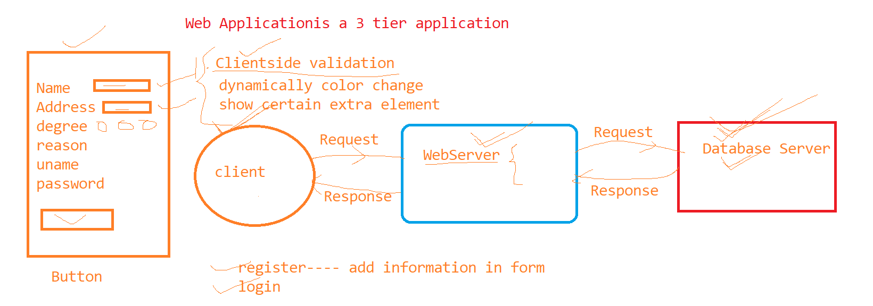

JavaScript

<script>

why to use Javascript

1. validation at client side
2. text box is empty
3. value of 2 textboxes is same or not
4. how check boxes have been checked
5. whether radio button is selected or not
6. email contains @ symbol
7. pattern matching
8. DOM manipulation (Document Object Model manipulation)
9. we want to change the background color based on event
10. display error message
11. hide or show portion of web page
12. after clicking on button add a row in the table

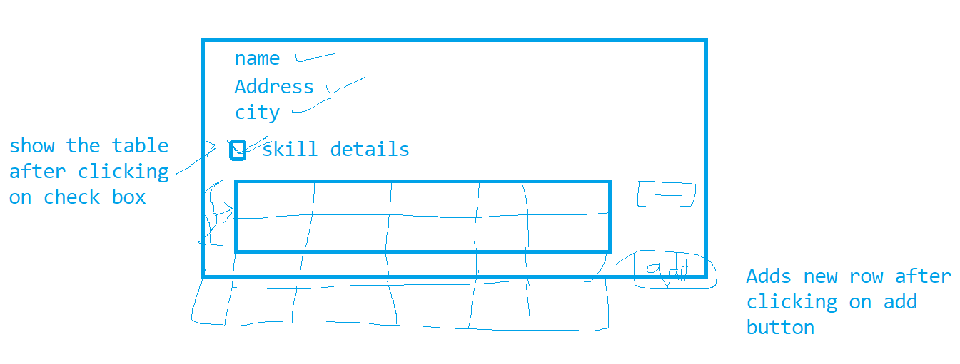

1. To send AJAX request

AJAX is used for populating portion of the page, to increase the speed of the website

in AJAX request Data comes in text or in JSON(Javascript object notation) format

XML –extensible markup language. it is used to store data. 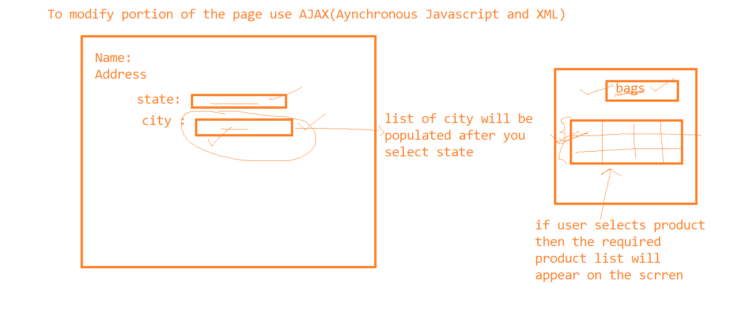

How to use Javascript

JavaScript is Client side technology as well as server side technology

But we are currently learning Client side javascript

To Javascript, It is of 2 types of scripts

1. Internal Javascript
2. External javascript

Internal javascript

* it is a script written inside HTML page, and added in <script> tag
* <script> tag can be added in <head> or <body> or outside body tag
* any number of script tags can be added in HTML page

<script> Javascript code…….</script>

External JavaScript

* If you write separate file with extension .js and add that file in HTML

<script src=”myjavascript.js”></script>

To display messages

then use

|  |  |
| --- | --- |
| document.write | Display message in browser window |
| console.log | Display message in console window |
| alert, prompt, confirm | Display message in popup windows, these are window object functions |

alert – it is a function to show popup with ok button

confirm --- it is a function to display popup window with 2 buttons ok and cancel

prompt ---- it is a function which displays popup window with text box and button

----To execute javascript as soon as page gets load then add script tag in side Body tag and write javascript code outside function

-----But to execute javascript based on users action then it is called as event handling

and for event handling put code inside a function and call the function at appropriate place

----javascript is event driven programming

In javascript you can declare variables to store data

var sum=0; //global varible

let sum=0; //blocked scope

Rules to declare variables

1. variable should start with alphabet or _
2. it can be combination of alphabet, digits or _
3. it is case sensitive
4. no official limit on length of variable name, but it must fit in one line
5. cannot include space or any other punctuation characters

For variables data type will be managed internally by javascript. It is dynamically typed language

----if in the program the data type is decided after assigning the value at run time then it is called as dynamically typed

var a=10; // number

a=”Kishori” ///string

a={id:123,name:”kishori,”desg:”manager”,sal:2345} //object

a=12/12/2000 ///date

a=[12,13,14,”aaa,”bbb”] //array

Basic datatype in javascript

* Number (4,4.345)
* String (“this is string”, ‘This is string’)
* Boolean (true/false)
* object ({id:123,name:”kishori,”desg:”manager”,sal:2345} )
* array ([12,13,14,15] or new Array(12,13,14,15))
* null to show absence of value

If you try to use variable without assigning the value to the variable then by default value is undefined

var a=null;

Operators in javascript

* unary operator(+,-,++,--)
* Arithmetic Operator (+,-,*,/,%)
* Assignment operator(=,+=,-=,*=,/=,%=)
* comparison operator(==,!=,<,>,<=,>=,===,!==)
  + //== ---checks value and === is strict checking it checks value as well as data type
  + //!= check value and !== id strict checking it checks value as well as data type
* Boolean operator ( &&, ||, !)
* Bitwise operators( &, |,^,<<,>>,>>>) /// >>> this will right shift the number and also add zeros on left side
* String operators (=, +, +=)
* ternary operator condition ? true:false

if statement

|  |  |  |
| --- | --- | --- |
| if(condition){  } | if(condition){  }else{  } | switch(variable){  case val1:  break;  case val2:  break;  .  ..  …  default:  } |

---In javascript every function has it own array with name arguments and all values which you pass to the function gets stored in arguments array

----for any event(user action) occurs then JavaScript generates the object with name event and to get extra information about event use event object.

|  |  |
| --- | --- |
| for(initialization;condition;increment/decrement){  } | To repeat statements |
|  |  |
|  |  |

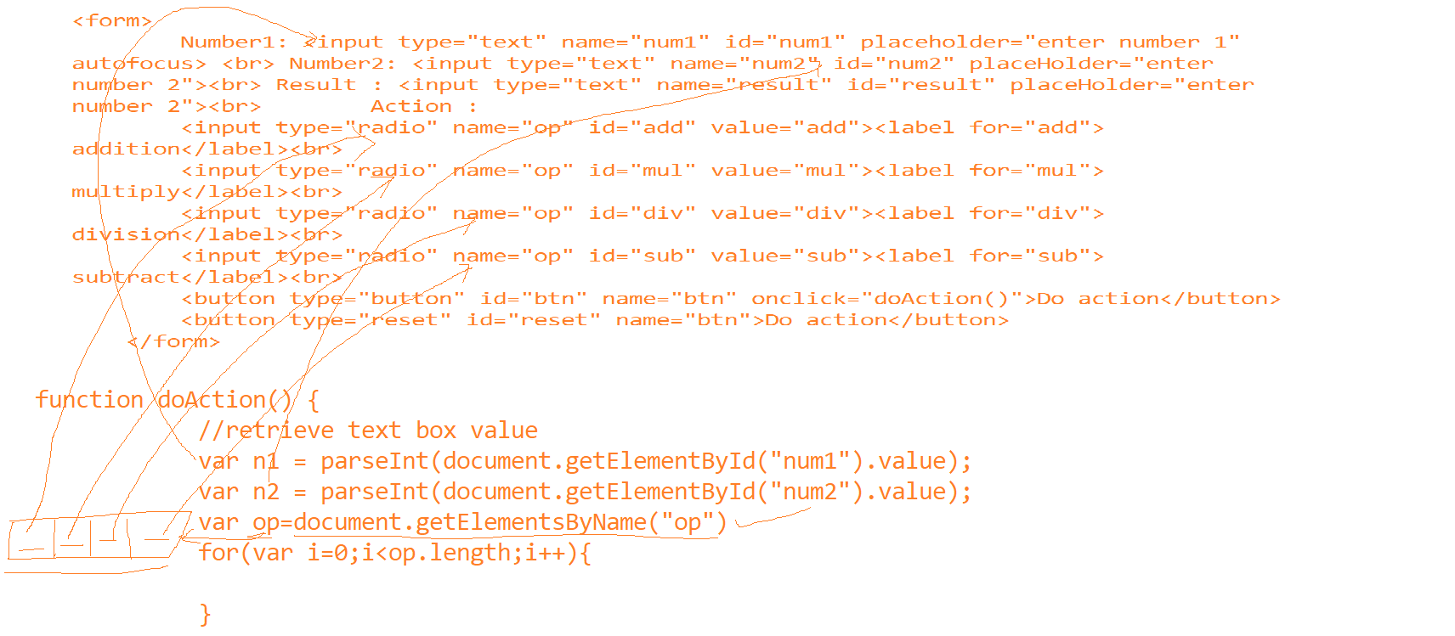

|  |  |
| --- | --- |
| Textbox,checkbox,radio button,select | value |
| P, div, span,h1,h2,h3,h4,h5,h6,ol,li,table | innerHTML |

If you can use the tag to accept data from user in the form then use property .value otherwise use .innerHTML

temple operator-

It is used for displaying formatted string

var a=12;

var b=24;

value of a is 12 and value of b is 24

“value of a is “+a+” and value of b is”+b; // using +(concat) operator

` value of a is ${a} and value of b is ${b}` //using temple operator

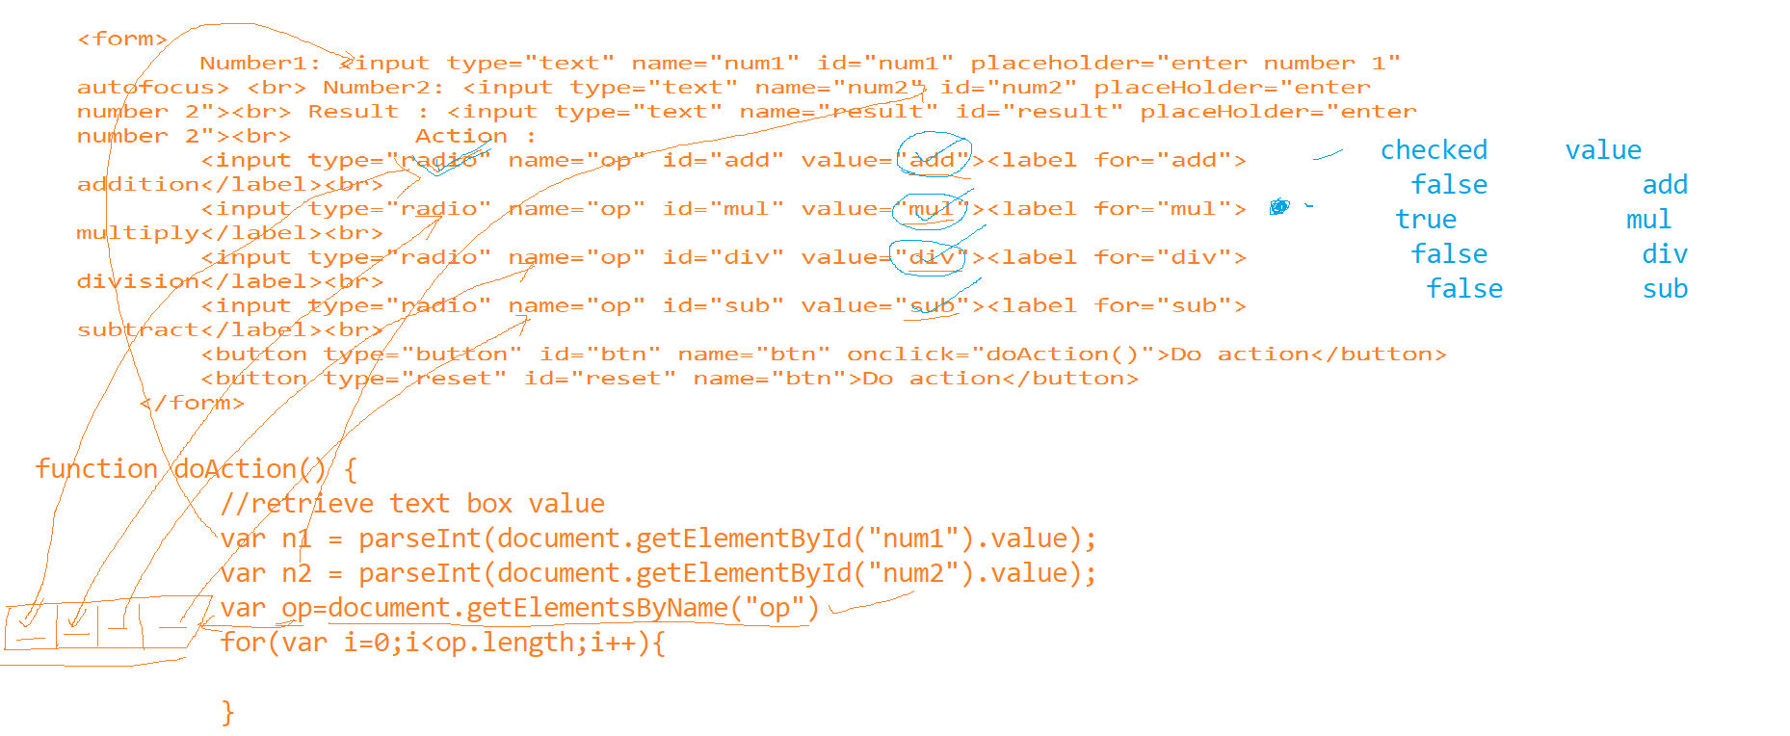

Built in functions

Number function

|  |  |  |
| --- | --- | --- |
| isNaN | Is not a number | It returns true if value contains any digit |
| parseInt() | To convert string to int |  |
| parseFloat() | To convert string to float |  |

topics for tomorrow’s session

difference between var and let

regexp

String functions in javascript

validations in javascript

arrays and functions in arrays and array operators

String function

objects in javascript

|  |  |  |
| --- | --- | --- |
| Function |  |  |
|  |  |  |
|  |  |  |
|  |  |  |
|  |  |  |
|  |  |  |
|  |  |  |